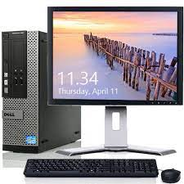

Dell Optiplex I3

* Genuine Windows 10
* Screen: 19" LCD
* 4GB Memory Drive:500 GB
* 4GB Memory
* **Rs.70,048**